High Level Architecture for S& OP Data Flow:

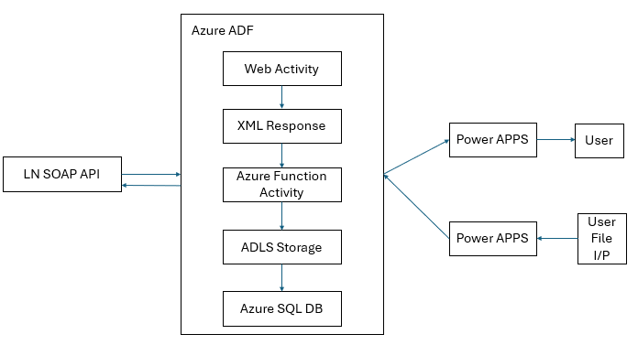

Azure Components required for this Data Flow

Resource Type | Resource Name | Remarks
Azure ADF | ELGI-ADF | Available
Azure Function App | ELGIBIFunctionApp | Needs to be Reconfigured to Central India Region and Python Runtime
ADLS Storage Account | storageaccountelgibi | Available

